Exercise: DOM Introduction
Submit your solutions in the SoftUni judge system at:
https://alpha.judge.softuni.org/contests/dom-introduction-exercise/2761
Environment Specifics
Please, be aware that every JS environment may behave differently when executing code. Certain things that work in the browser are not supported in Node.js, which is the environment used by Judge.
The following actions are NOT supported:
- .forEach() with NodeList (returned by querySelector() and querySelectorAll())
- .forEach() with HTMLCollection (returned by getElementsByClassName() and element.children)
- Using the spread-operator (...) to convert a NodeList into an array
- append() in Judge (use only appendChild())
- prepend()
- replaceWith()
- replaceAll()
- closest()
- replaceChildren()
- Always turn the collection into a JS array (forEach, forOf, et.)
If you want to perform these operations, you may use Array.from() to first convert the collection into an array.

Subtraction
An HTML page holds two text fields with ids "firstNumber" and "secondNumber". Write a function to subtract the values from these text fields and display the result in the div named "result".

HTML and JavaScript Code
Implement the above to provide the following functionality:
- Your function should take the values of "firstNumber" and "secondNumber", convert them to numbers, subtract the second number from the first one and then append the result to the <div> with id="result".
- Your function should be able to work with any 2 numbers in the inputs, not only the ones given in the example.

Example
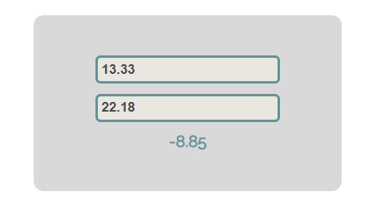

Hints
We see that the textboxes and the div have id attributes on them.
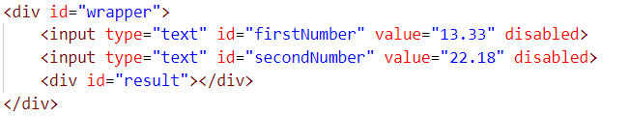
We can take the numbers directly from the input field by using the getElementById() function. After we have taken the elements from the DOM, it’s time to do the actual work. We get the values of the two textboxes, as one would expect, the type is text. To get a number, we need to use a function to parse them.
All that’s left for you to do is append the result to the div.

Pascal or Camel Case
An HTML file is given and your task is to write a function that takes two string parameters as an input and transforms the first parameter to the type required by the second parameter.
- The first parameter will be the text that you need to modify depending on the second parameter. The words in it will always be separated by space.
- The second parameter will be either "Camel Case" or "Pascal Case". In case of different input, your output should be "Error!"
When the button is clicked the function should convert the first string to either of the cases. The output should consist of only one word - the string you have modified. Once your output is done, you should set it as HTML to the <span> element. For more information, see the examples below:

Example
Input | Output
"this is an example", "Camel Case" | thisIsAnExample
"secOND eXamPLE", "Pascal Case" | SecondExample
"Invalid Input", "Another Case" | Error!

Hints
First, take the two values from the input fields:
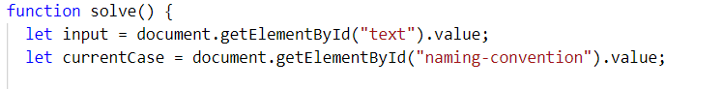
Then, write a function that generates the result:
- First, convert all the letters to lowercase
- Depending on the command, make the input either Pascal Case or Camel Case
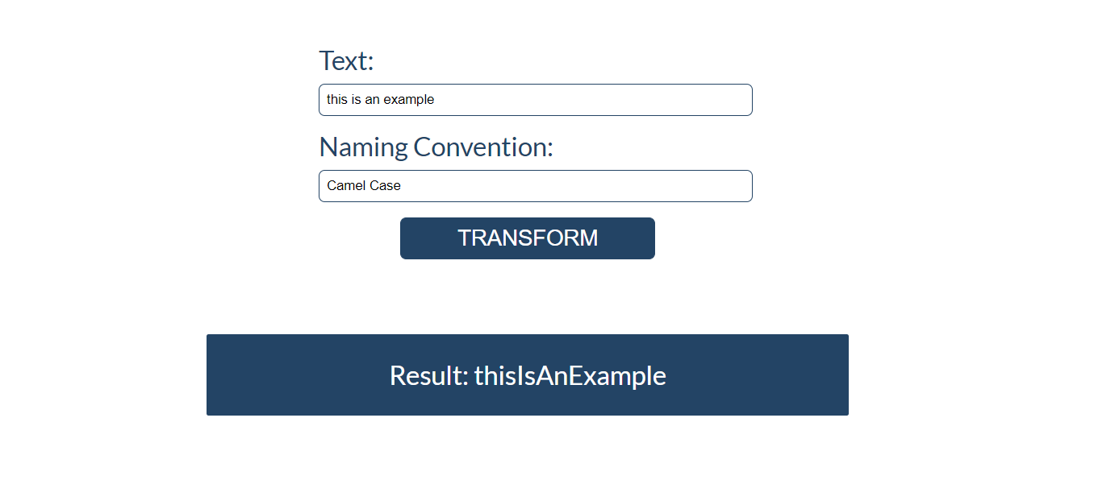

Accordion
An HTML file is given and your task is to show more/less information. By clicking the [More] button, it should reveal the content of a hidden div and changes the text of the button to [Less]. When the same link is clicked again (now reading Less), hide the div and change the text of the link to More. Link action should be toggleable (you should be able to click the button an infinite amount of times).

Example
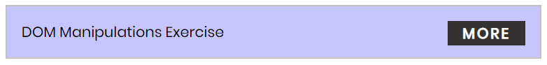
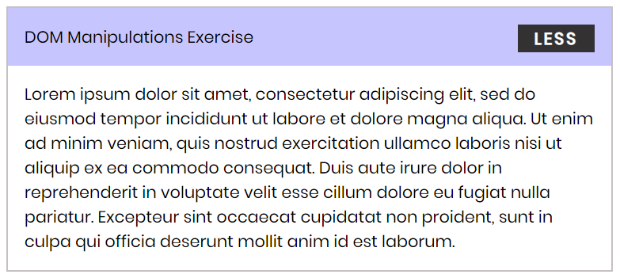

Hints
- To change the text content of a button, you could use getElementsByClassName. However, that returns a collection and we need only one element from it, so the correct way is to use getElementsByClassName("button")[0] as it will return the needed span element.
- After that, we should change the display style of the div with an id "extra". If the display style is "none", we should change it to "block" and the opposite.
- Along with all of this, we should change the text content of the button to [Less]/[More].

Search in List

An HTML page holds a list of towns, a search box, and a [Search] button. Implement the search function to bold and underline the items from the list which include the text from the search box. Also, print the number of items the current search matches in the format `${matches} matches found`.
Note: It is necessary to clear the results of the previous search.
Write your JavaScript code in this file:
search.js
function search() {
// TODO
}

Screenshots
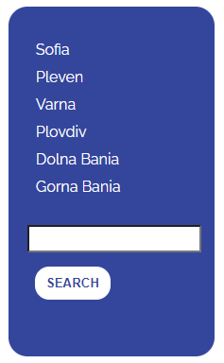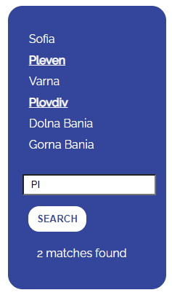

Table - Search Engine
Write a function that searches in a table by given input.
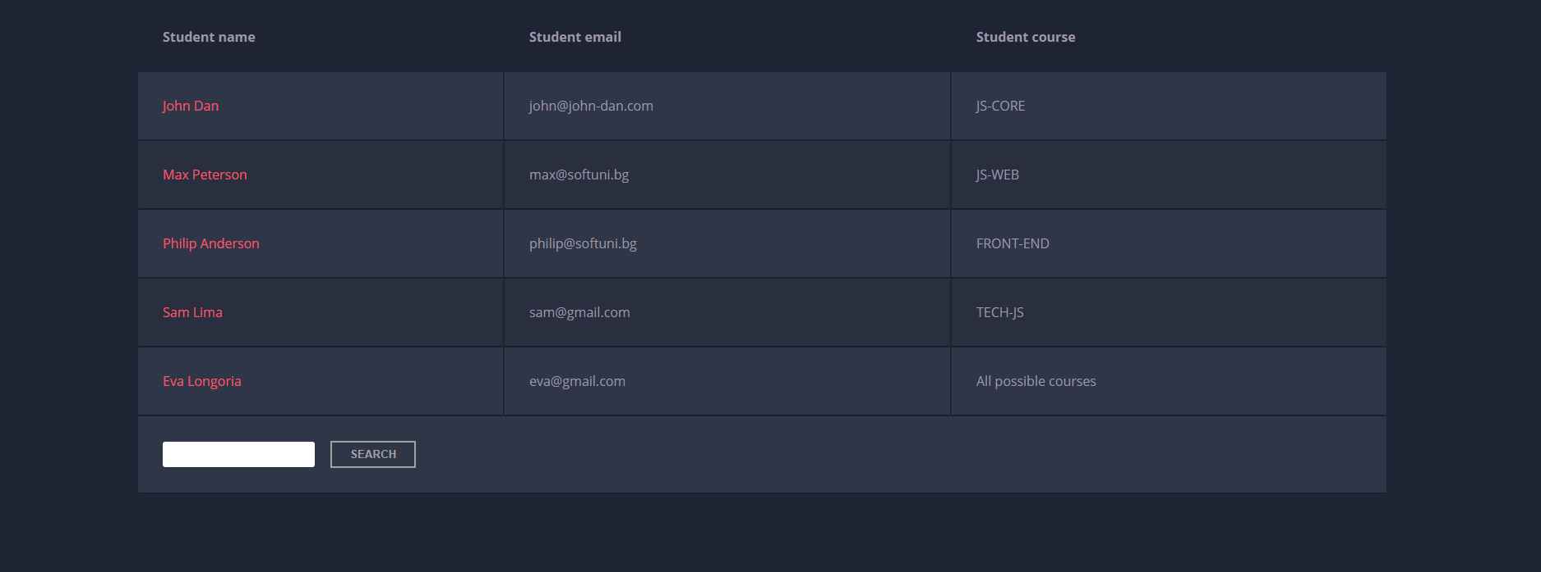
When the "Search" button is clicked, go through all cells in the table except for the first row (Student name, Student email, and Student course) and check if the given input has a match (check for both full words and single letters). If the input is an empty string, no rows should be selected or highlighted.
If any of the rows contain the submitted string, add a class select to that row. Note that more than one row may contain the given string.
Оtherwise, if there is no match, nothing should happen.
Note: After every search ("Search" button is clicked), clear the input field and remove all already selected classes (if any) from the previous search, for the new search to contain only the new result.
For instance, if we try to find eva:
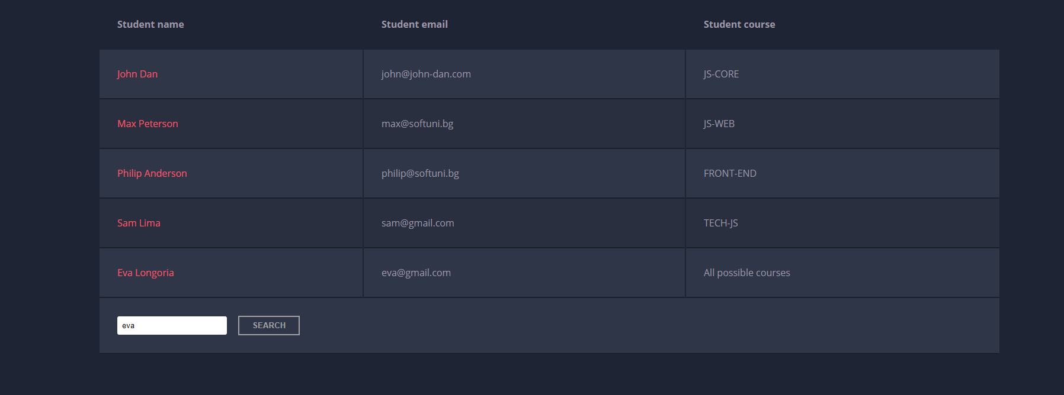
The result should be:
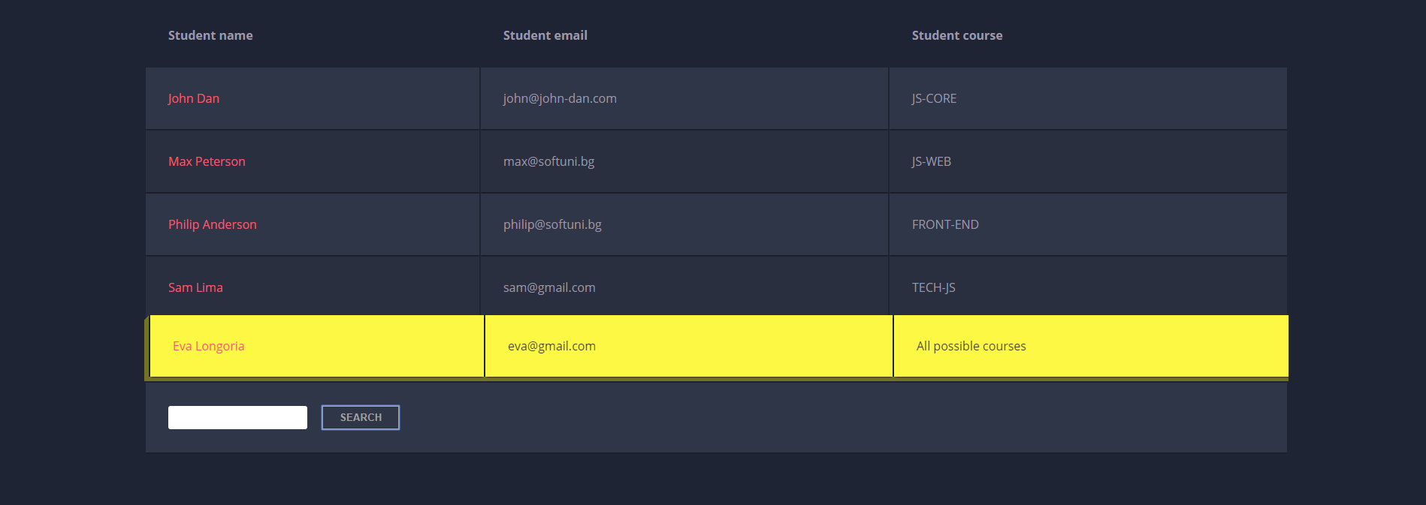
If we try to find all students who have email addresses in softuni domain, the expected result should be:
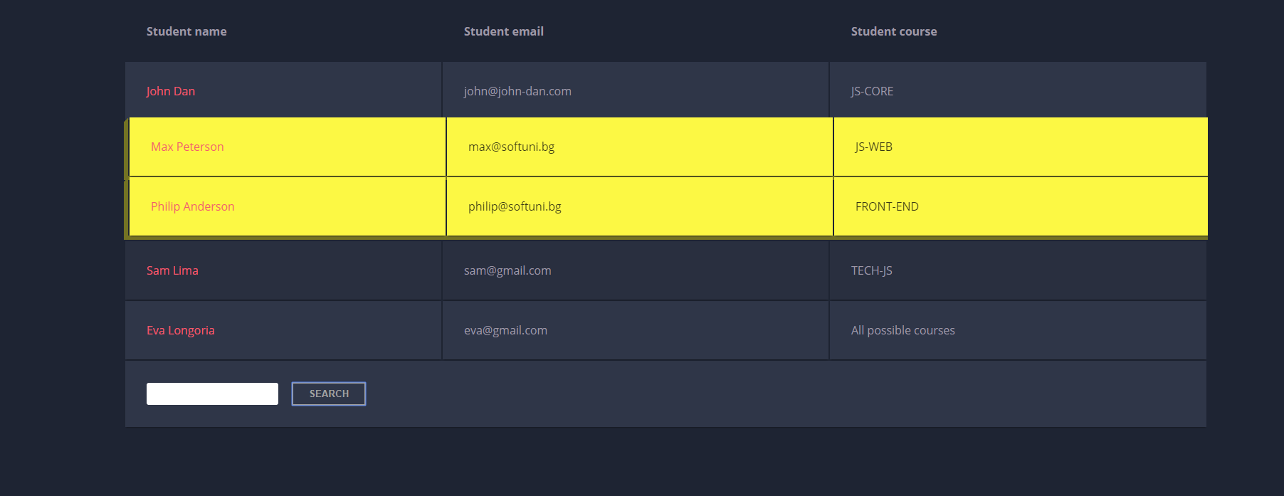

Format the Text
Create a functionality that gets a text from textarea, formats the given text - you need to find out how many sentences there are in the text, simply split the whole text by '.'
Also, every sentence must have at least 1 character.
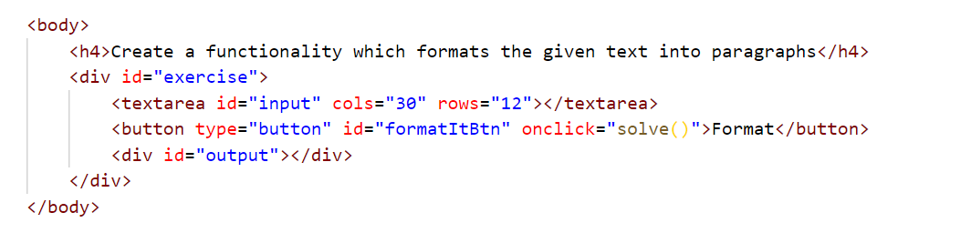
Generate HTML paragraphs as a string (Use interpolation string to create paragraph element: `<p> {text} </p>`) and append it to the div with an id = "output".
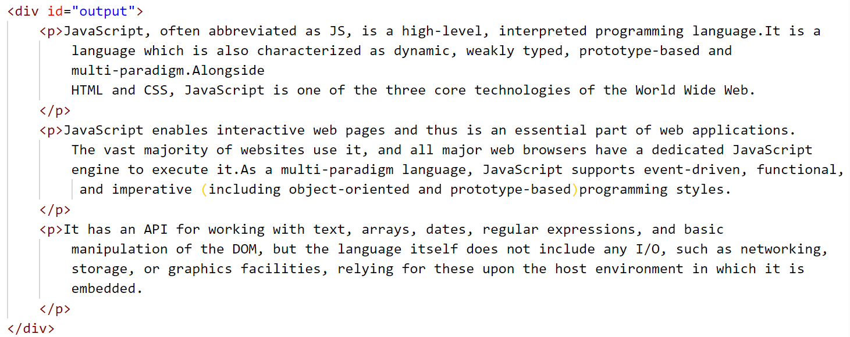
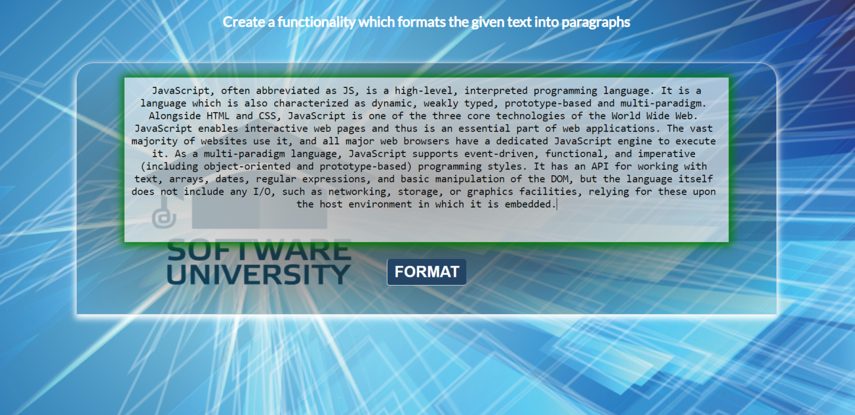
When the [Format] button is clicked, get the text inside the textarea with an id="input" and format it. The formatting is done as follows:
- Create a new paragraph element that holds no more than 3 sentences from the given input.
- Hint: Use interpolation string to create paragraph element. (`<p> {text} </p>`)
- If the given input contains less or 3 sentences, you need to create only 1 paragraph, fill it with these sentences and append this paragraph to the div with an id="output".
Otherwise, when you have more than 3 sentences, create enough paragraphs to get all sentences from the textarea.
Just remember to restrict the sentences in each paragraph to 3.

Example:
- If the input textarea contains 2 sentences, create only 1 paragraph with these 2 sentences
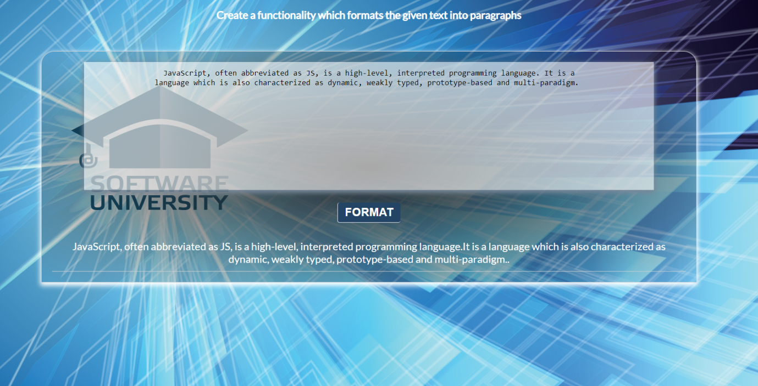
- If the input textarea contains 7 sentences, create 3 paragraphs
- The first paragraph must contain the first 3 sentences
- The second paragraph must contain the other three sentences of the whole text
- The third paragraph will contain only the last sentence
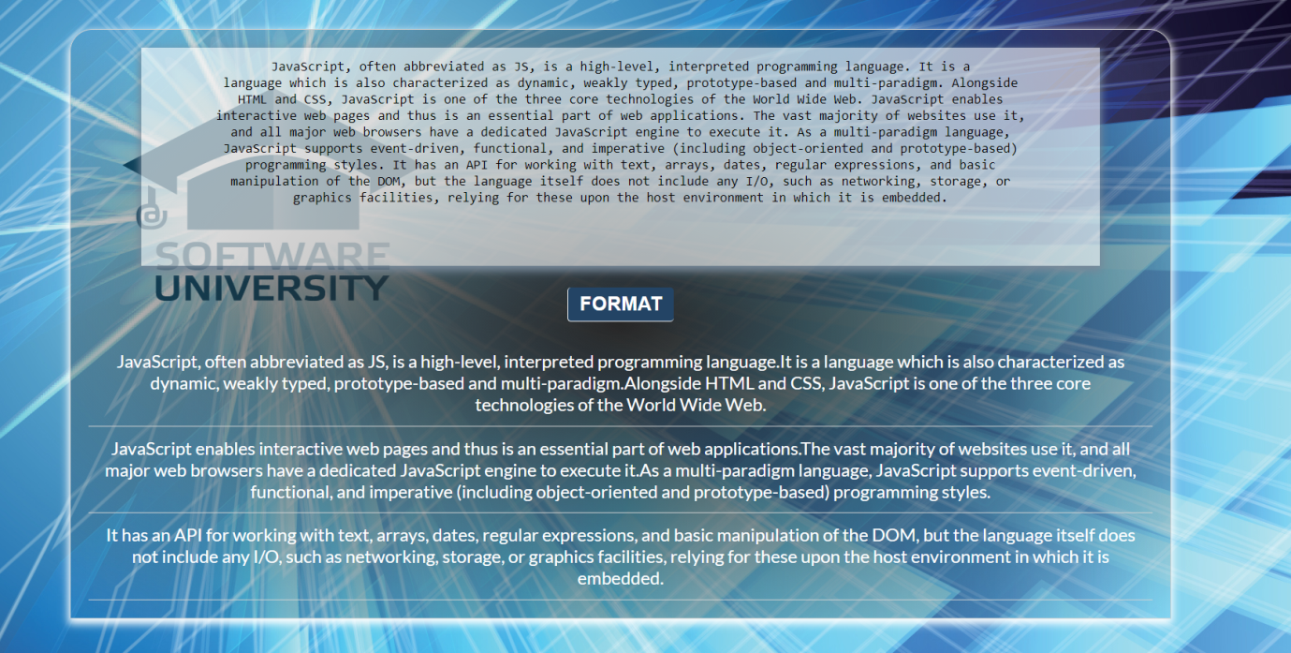

Input / Output
Input | Output
JavaScript, often abbreviated as JS, is a high-level, interpreted programming language. It is a language which is also characterized as dynamic, weakly typed, prototype-based and multi-paradigm. | <p>JavaScript, often abbreviated as JS, is a high-level, interpreted programming language. It is a language which is also characterized as dynamic, weakly typed, prototype-based and multi-paradigm.</p>
JavaScript, often abbreviated as JS, is a high-level, interpreted programming language. It is a language which is also characterized as dynamic, weakly typed, prototype-based and multi-paradigm. Alongside HTML and CSS, JavaScript is one of the three core technologies of the World Wide Web. JavaScript enables interactive web pages and thus is an essential part of web applications. The vast majority of websites use it, and all major web browsers have a dedicated JavaScript engine to execute it. As a multi-paradigm language, JavaScript supports event-driven, functional, and imperative (including object-oriented and prototype-based) programming styles. It has an API for working with text, arrays, dates, regular expressions, and basic manipulation of the DOM, but the language itself does not include any I/O, such as networking, storage, or graphics facilities, relying for these upon the host environment in which it is embedded. | <p>JavaScript, often abbreviated as JS, is a high-level, interpreted programming language.It is a  language which is also characterized as dynamic, weakly typed, prototype-based and multi-paradigm.Alongside  HTML and CSS, JavaScript is one of the three core technologies of the World Wide Web.</p>  <p>JavaScript enables  interactive web pages and thus is an essential part of web applications.The vast majority of websites use it,  and all major web browsers have a dedicated JavaScript engine to execute it.As a multi-paradigm language,  JavaScript supports event-driven, functional, and imperative (including object-oriented and prototype-based)  programming styles.</p>  <p>It has an API for working with text, arrays, dates, regular expressions, and basic  manipulation of the DOM, but the language itself does not include any I/O, such as networking, storage, or  graphics facilities, relying for these upon the host environment in which it is embedded.</p>

Hell's Kitchen

You will be given an array of strings, which represents a list of all the restaurants with their workers.
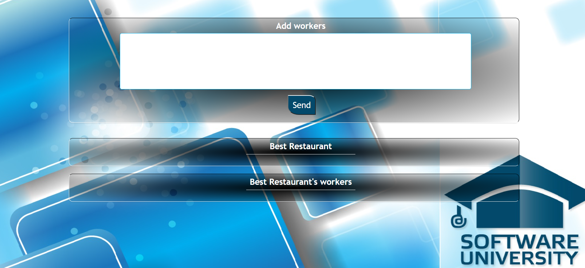
When the [Send] button is clicked:
- Display the best restaurant of all the added restaurants with its average salary and best salary.
- If there is a restaurant in the input array that is added more than once, you need to add new workers to the old ones and update the values of the average salary and the best salary.
- The best restaurant is the restaurant with the highest average salary. If two restaurants have the same average salary the best restaurant is the first one added.
- Display all workers in the best restaurant with their salaries.
The best restaurant's workers should be sorted by their salaries in descending order.
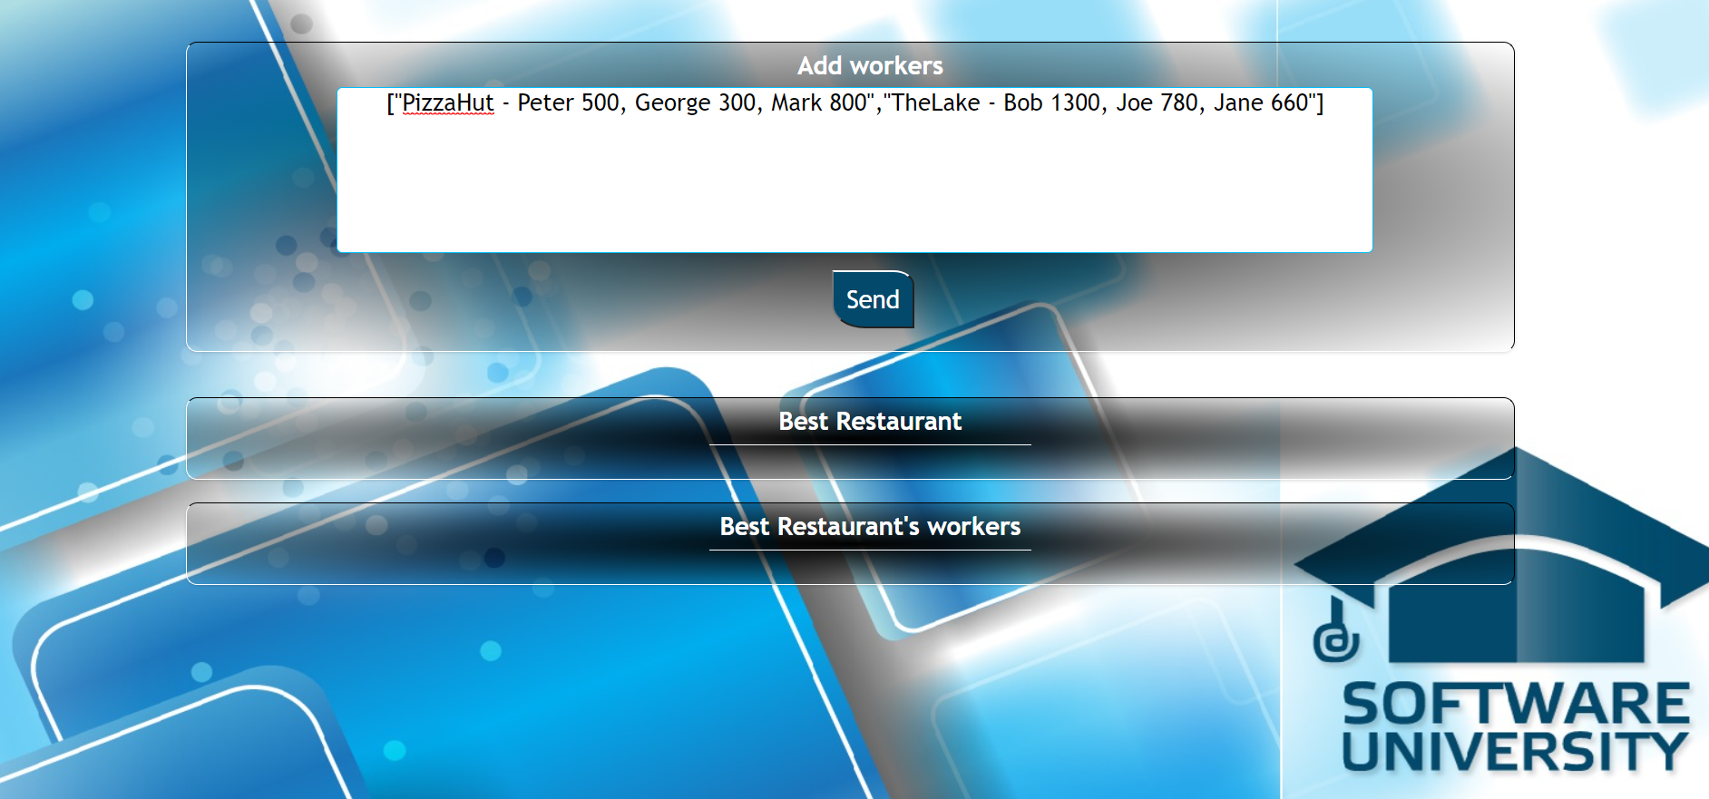

Input
The input will be received from the given textarea in the form of an array of strings. Each string represents a restaurant with its workers: ["Mikes - Steve 1000, Ivan 200, Paul 800", "Fleet - Maria 850, Janet 650"]
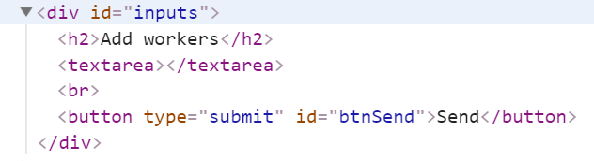
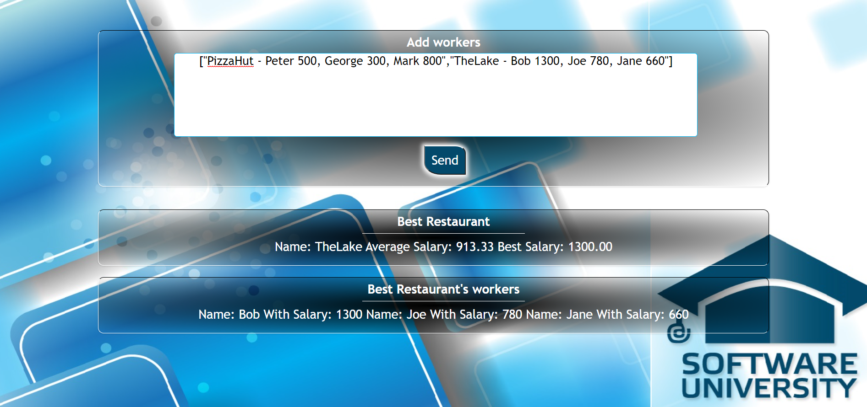

Output
- The output contains two strings
  - The first one is the best restaurant in the format:
`Name: {restaurant name} Average Salary: {restaurant avgSalary} Best Salary: {restaurant bestSalary}`
avgSalary and bestSalary must be formatted to the second decimal point.
  - The second one is all the workers in that restaurant in the following format:
`Name: {worker name} With Salary: {worker salary} Name: {worker2 name} With Salary: {worker2 salary} Name: {worker3 name} With Salary: {worker3 salary}…`
Output strings must be set like text content in the following elements:
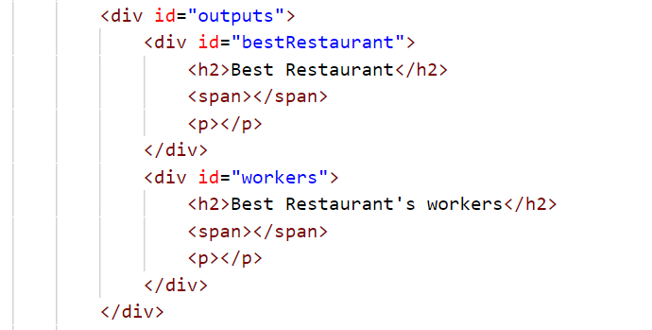

Constraints
- The workers will be always unique

Examples
Input | Output | Comment
["PizzaHut - Peter 500, George 300, Mark 800",  "TheLake - Bob 1300, Joe 780, Jane 660"] | Name: TheLake Average Salary: 913.33 Best Salary: 1300.00  Name: Bob With Salary: 1300 Name: Joe With Salary: 780 Name: Jane With Salary: 660 | The added restaurants are: TheLake and PizzaHut.  TheLake has average salary:  (1300+780+660)/3= 913.33,  and PizzaHub has average salary:  (500+300+800)/2=533.33.  So the best restaurant is TheLake.
["Mikes - Steve 1000, Ivan 200, Paul 800","Fleet - Maria 850, Janet 650"] | Name: Fleet Average Salary: 750.00 Best Salary: 850.00  Name: Maria With Salary: 850 Name: Janet With Salary: 650

Generate Report
You will be given a web page, containing a table and output area.
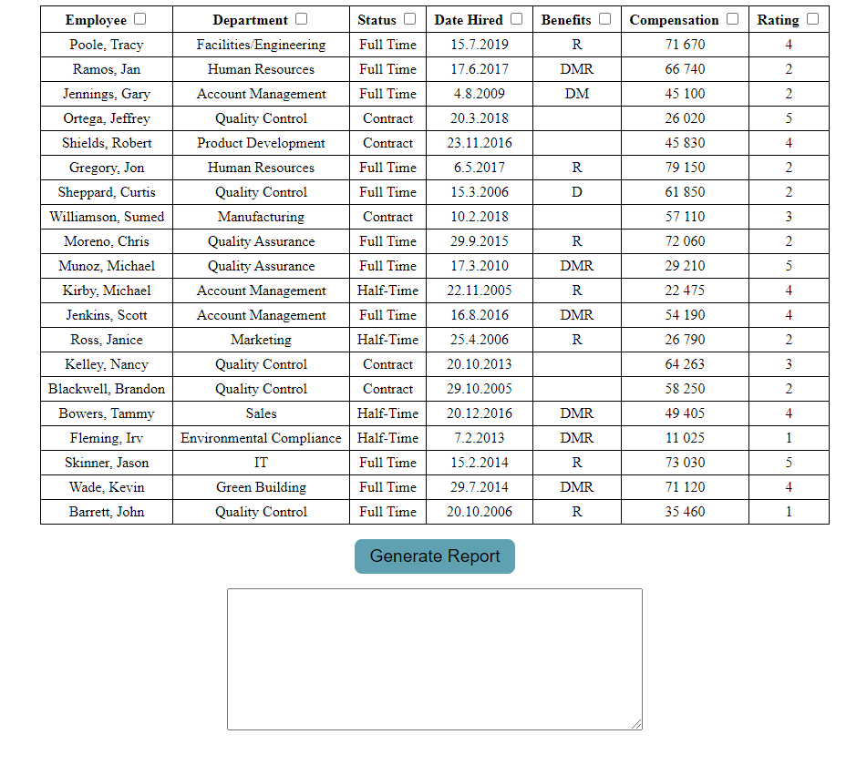
When the "Generate Report" button is pressed:
- You must generate a JSON report from the data inside the table, by only taking the columns, which are selected.
Each table header has a checkbox. If the checkbox is checked, then the data from this column must be included in the report. Unchecked columns must be omitted.
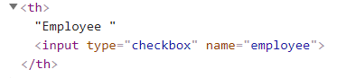
For every row (excluding the header):
- Create an object with properties for each of its columns.
- The name of each property is the name attribute of the column’s header, and the value is the text content of the cell.
- Store the result in an array and output it as a JSON string display it inside the <textarea> with id "output". See the example for details.
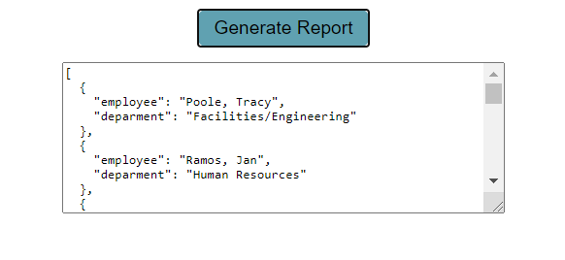

Input / Output
There will be input, your program must execute based on the page content. The output must be a JSON string, displayed in the <textarea> with id "output".
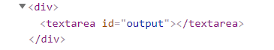

Example
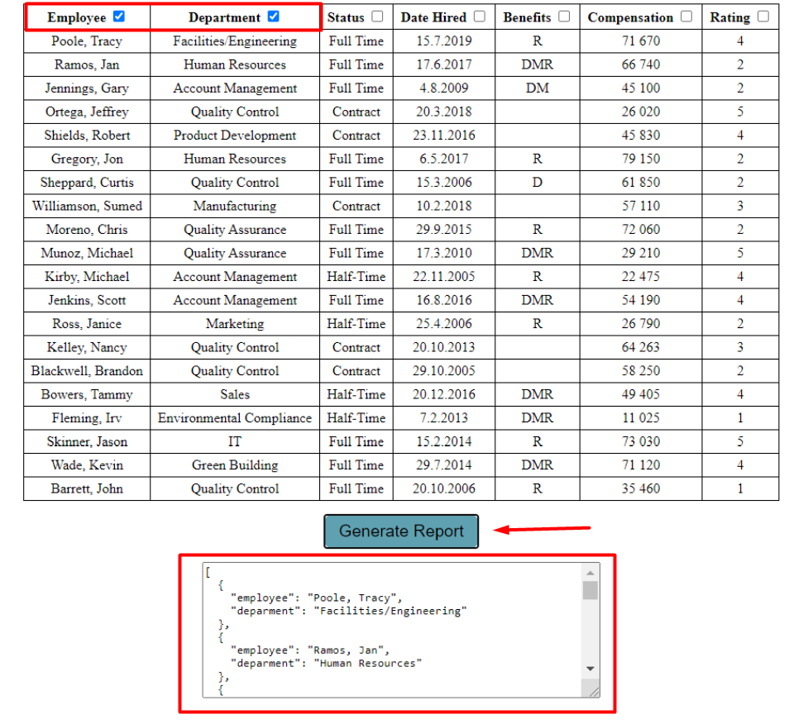

*Number Convertor
Write a function that converts a decimal number to binary and hexadecimal.

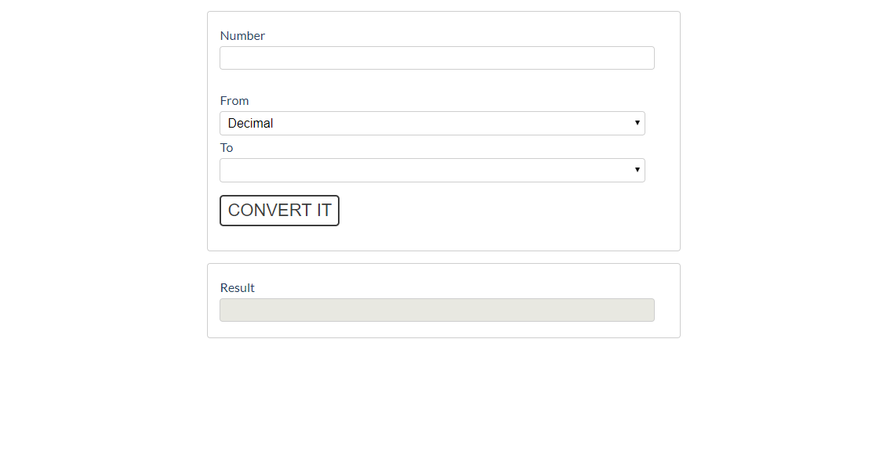
The given number will always be in decimal format. The "From" select menu will only have a Decimal option,
but the "To" select menu will have two options: Binary and Hexadecimal.
This means that our program should have the functionality to convert decimal to binary and decimal to hexadecimal. When you convert to hexadecimal it must be upper case.
Note that the "To" select menu by default is empty. You have to insert the two options ('Binary' and 'Hexadecimal') inside before continuing. Also, they should have values ('binary' and 'hexadecimal').
- When the [Convert it] button is clicked, the expected result should appear in the [Result] input field.
